**WEEK 1 DISTRIBUTED COMPUTING - DATA FRAME, RUNNING SQL QUERIES AND SCALE USING SPARK**

* 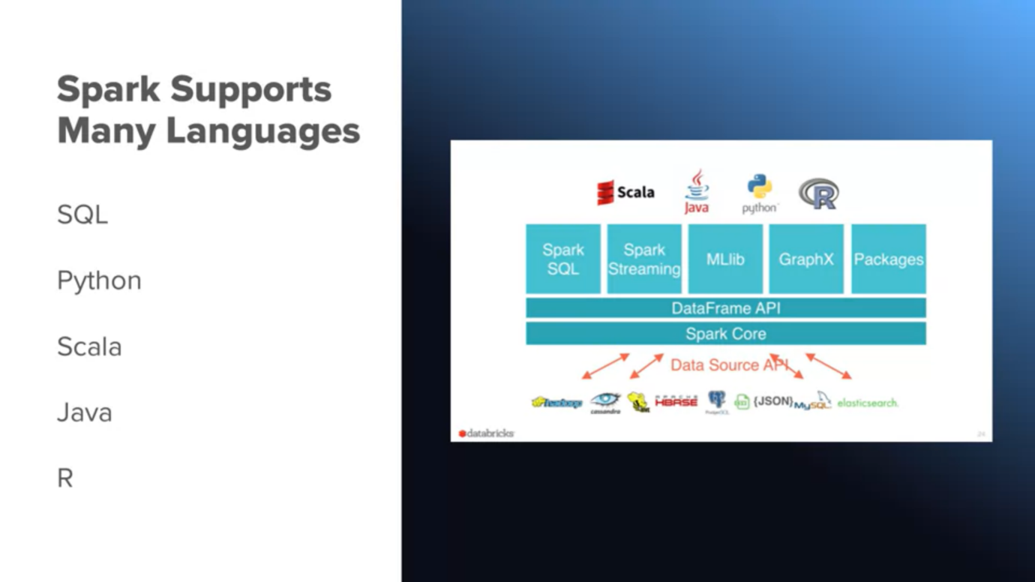Volume [size] – Velocity [Speed] – Variety [Datatype] – Veracity [validity of data &| source]

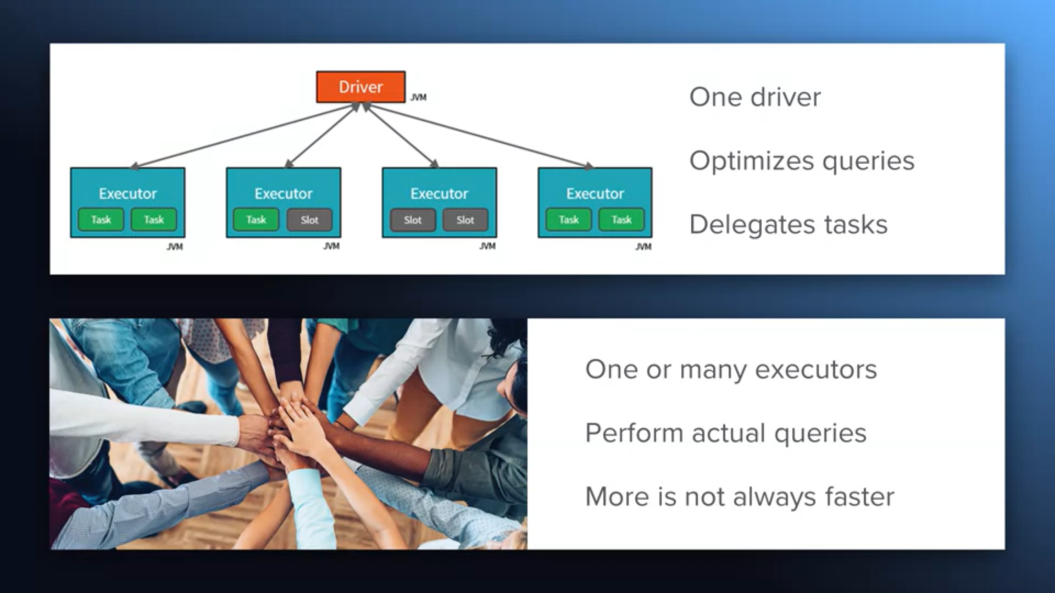

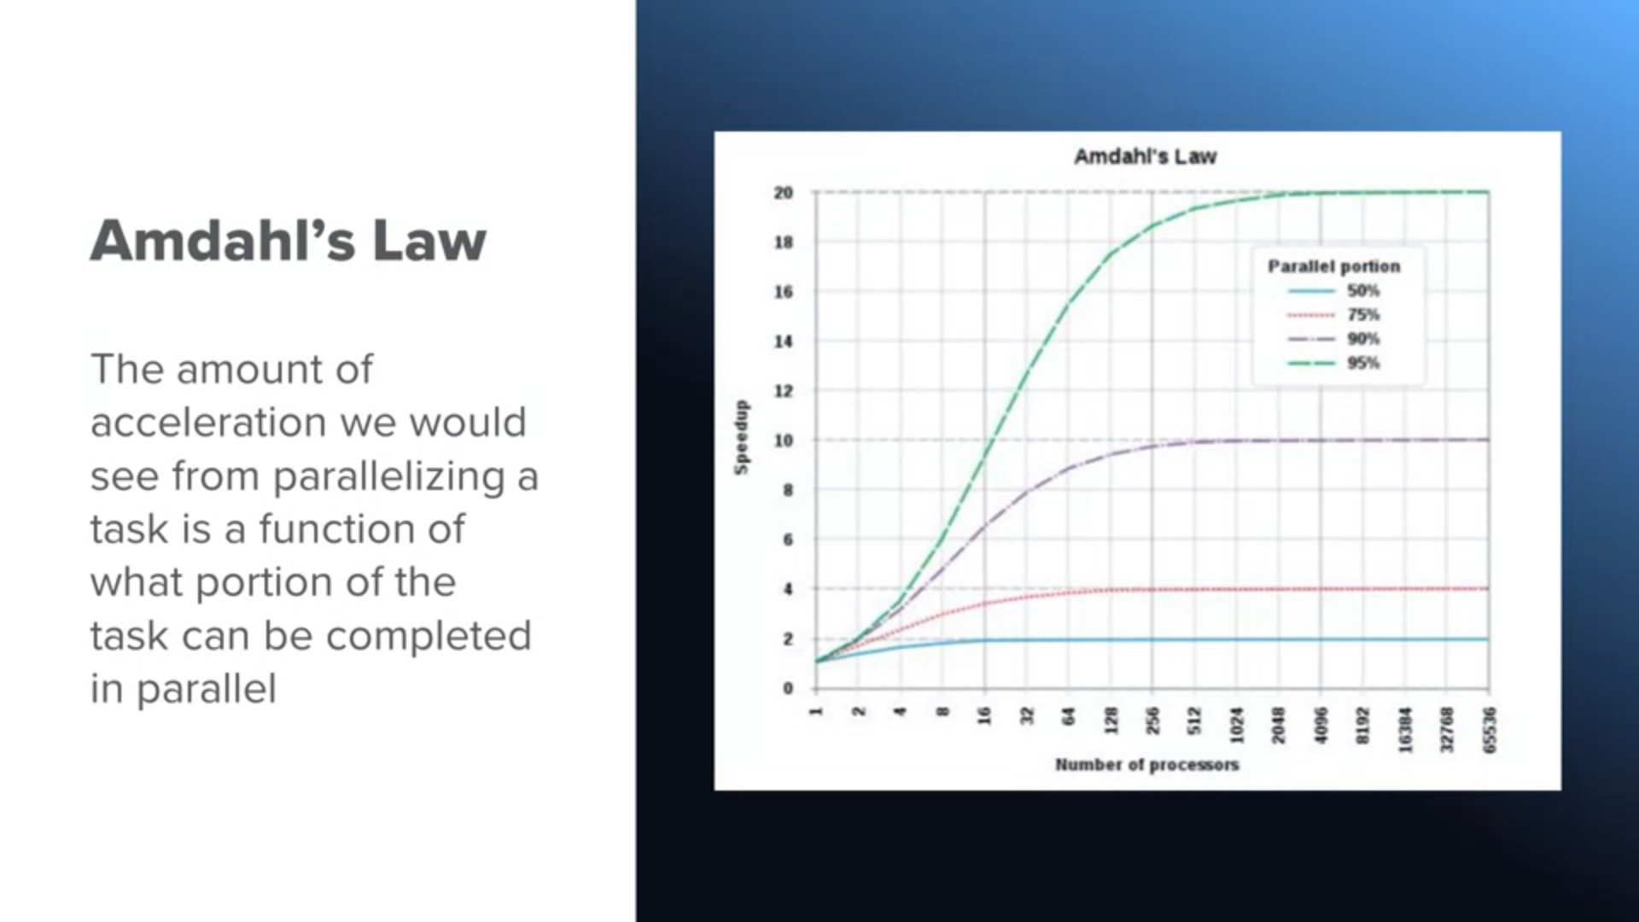

**Resilient Distributed Datasets**

* Acyclic chunks of computations – fault
* Distributed dataset across executers – each one operates on their share of data

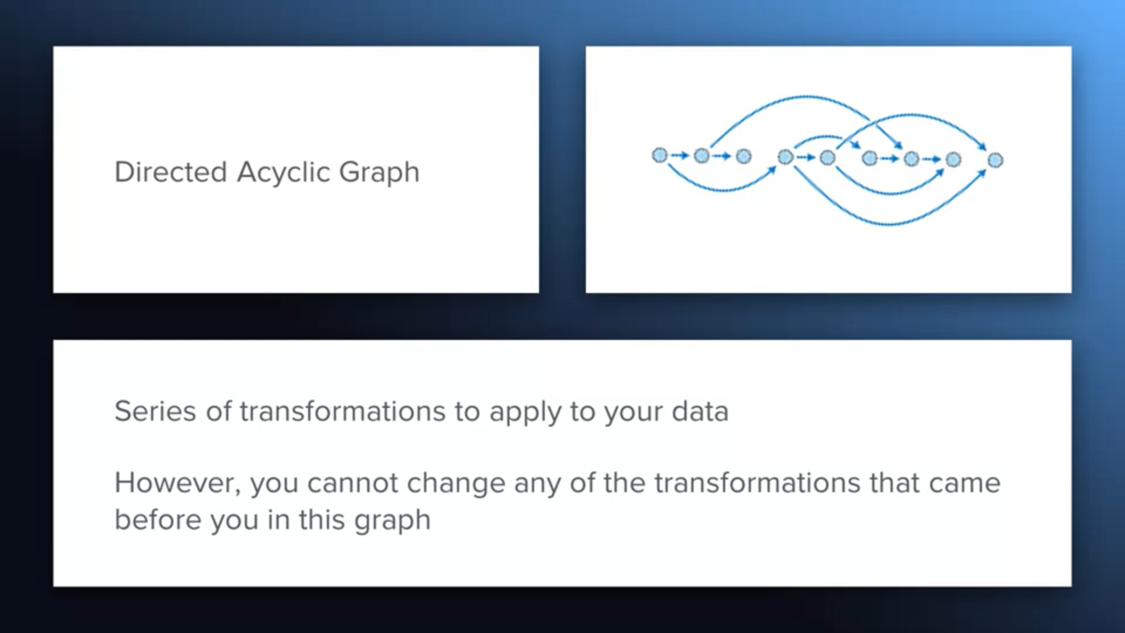

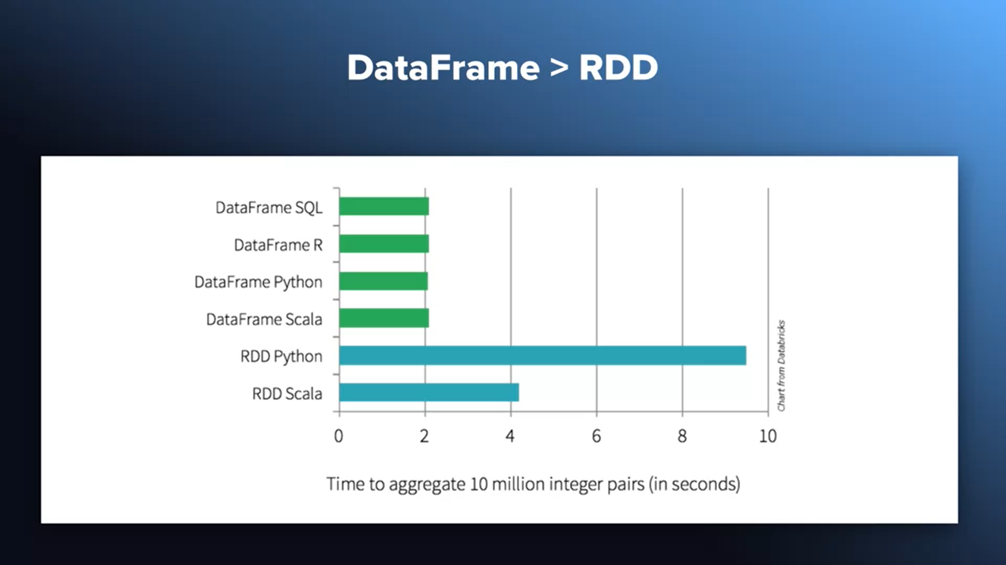

**Spark is declarative [WHAT] rather than imperative[HOW]**

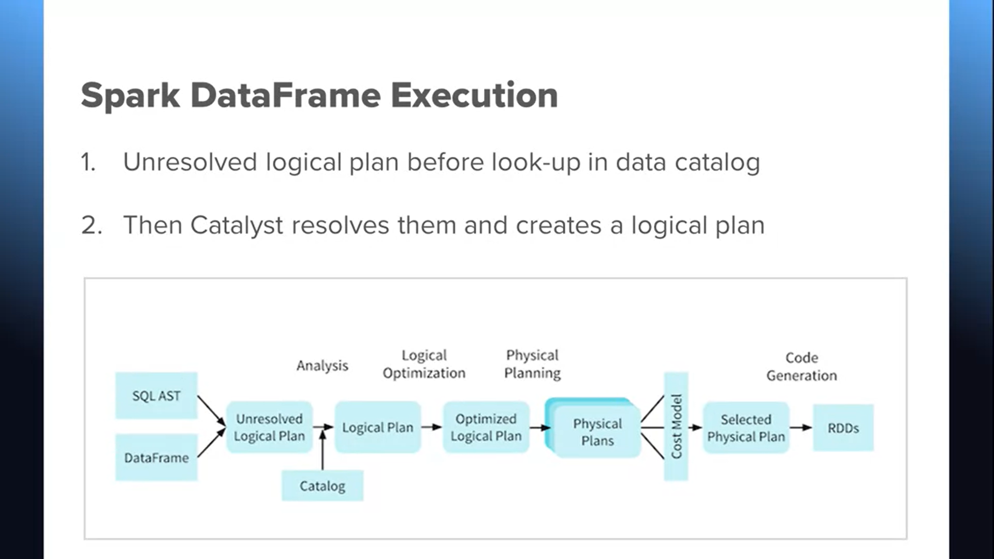

**Databricks manages:**

1. **Networking clusture**
2. **Easily deploy spark environment on AWS, Azure**

**Readings and Resources**

**Course Notebooks:**

* [**https://files.training.databricks.com/courses/davis/Lessons.dbc**](https://files.training.databricks.com/courses/davis/Lessons.dbc)

**R​eadings**

* [**S​park SQL and DataFrames and Datasets Guides**](https://spark.apache.org/docs/latest/sql-programming-guide.html)
* [**S​QL Guide from Databricks**](https://docs.databricks.com/spark/latest/spark-sql/index.html)

**Additional R​esources**

* **This is an optional resource that you could consider purchasing from this seller. This link is to get you started on an eBook version that does have a free trial option.**[**S​park: The Definitive Guide**](http://shop.oreilly.com/product/0636920034957.do)
* **This is a free gitbook:**[**Introduction - The Internals of Spark SQL**](https://jaceklaskowski.gitbooks.io/mastering-spark-sql/)**.**

**WEEK 2 SQL FOR SPARK - CACHING, DEBUG SLOW QUERIES WITH SPARK UI**

**In local mode, Spark Driver-Executer can be**

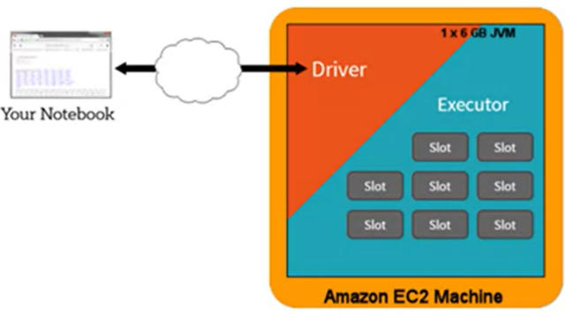**single Compute instance TDM**

**Slot is essentially thread of execution**

* **M**achines * **C**ores * **T**hreads

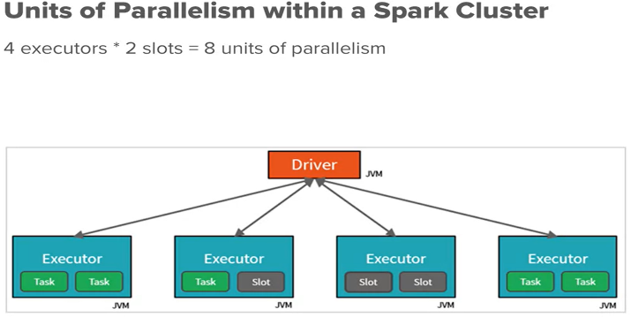**In production, Spark clusters runs multiple compute instances**

**Partitions are Units of parallelism of data – they are subsets of data distributed across system [Count depends on size, feature governing partitions, cluster config]**

* Designing partition size is handled by Databricks – Its tricky to balance **Computation**[Data/ compute] and **communication**[Number of compute cycles]

**Cached Table: Entire table data partitioned and saved for faster access**

* Project Tungsten optimizes Data
* All data partitions are materialized

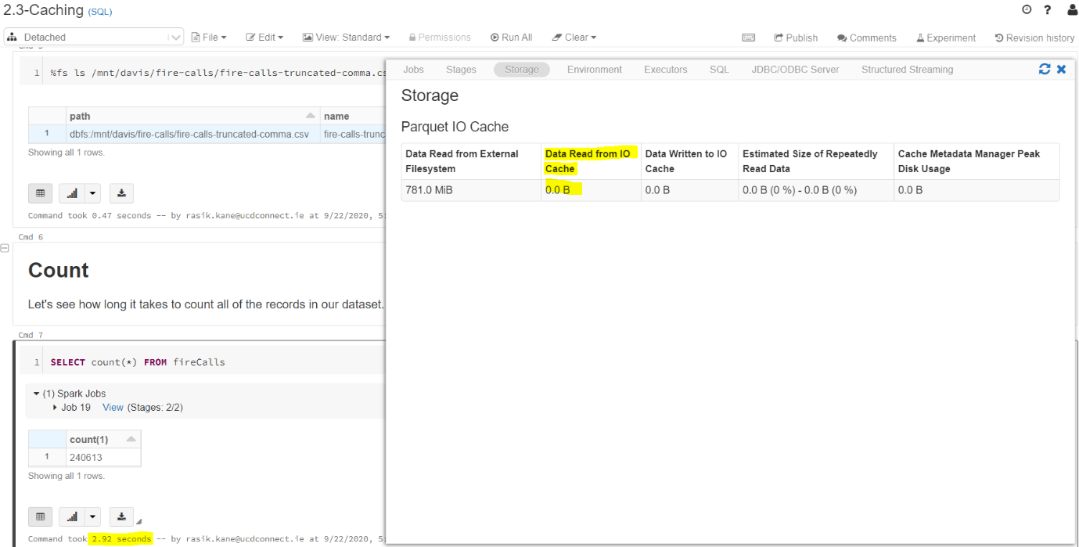

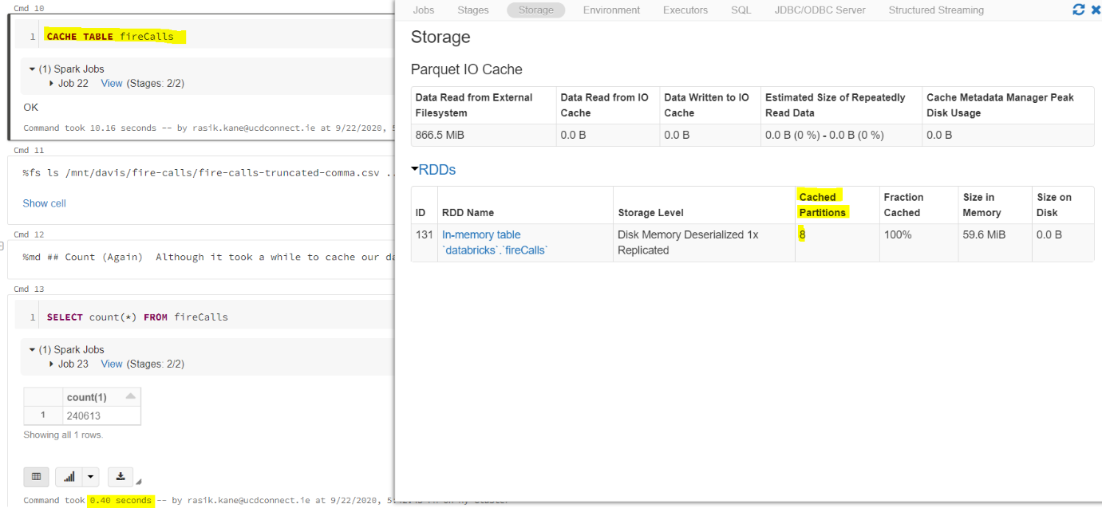

**Lazy Cache Table: Only data view recently queried is considered for caching**

* 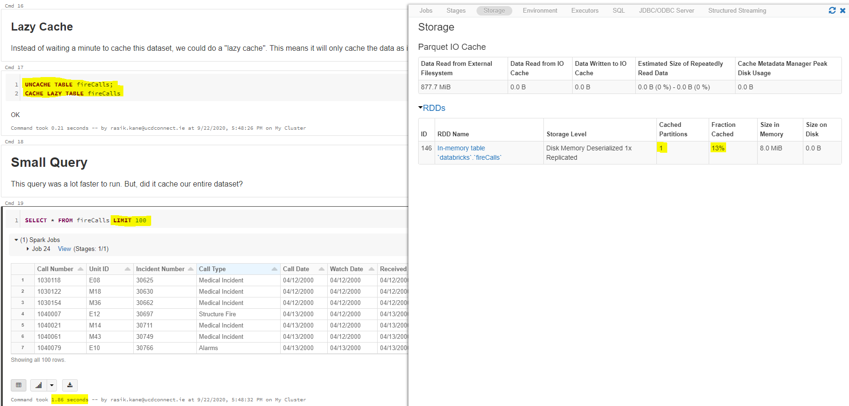**As data is queried; more and more partitions are materialized [physically created in cache]**

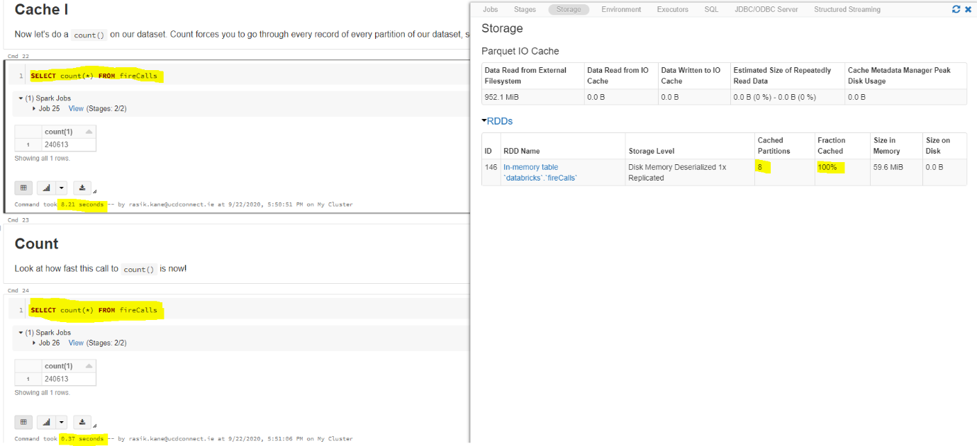

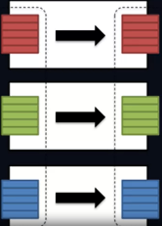**Narrow Transformation [In-Partition]**

* Transform locally - eg. Select, Where
* Filter operations done on all partitions in parallel

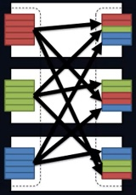**Wide transformation [cross-Partition]**

* Aggregation operation – eg. Groupby, orderby
* Data shuffle required
* **Default shuffle partition is 200**
* **work 🡪 shuffle (write) results to local disc 🡪 shuffle (read) using 200 tasks 🡪 output formed aggregating 200 partitions**

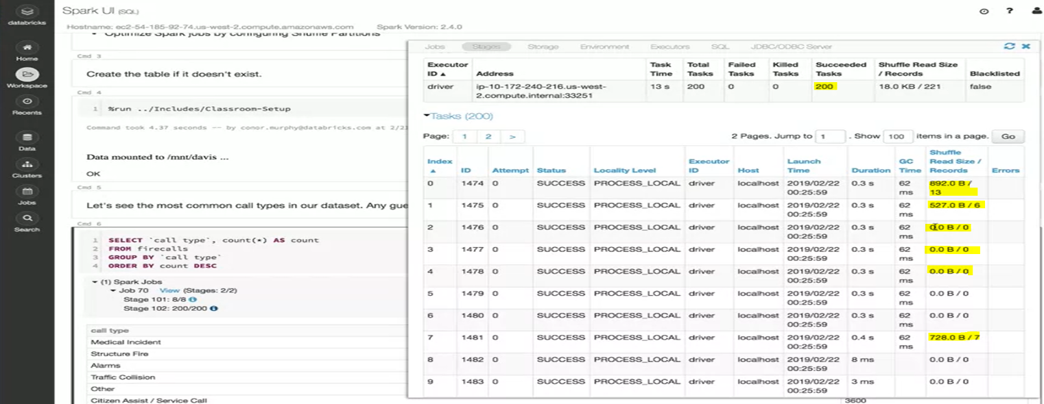**spark.sql.shuffle.partitions** parameter controls how many resulting partitions there are after a shuffle (wide transformation).

**Broadcast Joins decrease data shuffle 🡪 decrease query time**

* Spark analyses **data size** and using this heuristics, it decides type of JOIN operation
  + Default size limit for opting broadcast is 10MB

%python

spark.conf.get("spark.sql.autoBroadcastJoinThreshold")

>> ‘10485760b’

* + Can be enforced by :

SELECT /*+ BROADCAST(fireCalls) */ *

FROM < T1_name >

JOIN <T2_name>on T1_name.dimension1 = T2_name.dimension2

### **R​eadings**

* [Deep Dive into Spark SQL’s Catalyst Optimizer](https://databricks.com/blog/2015/04/13/deep-dive-into-spark-sqls-catalyst-optimizer.html)
* [C​ost Based Optimizer in Apache Spark 2.2](https://databricks.com/blog/2017/08/31/cost-based-optimizer-in-apache-spark-2-2.html)
* [U​nderstanding your Apache Spark Application Through Visualization](https://databricks.com/blog/2015/06/22/understanding-your-spark-application-through-visualization.html)

**WEEK 3 ENGINEERING DATA PIPELINES - ETL, SCHEMAS, FILE FORMATS, JDBC PROTOCOL**

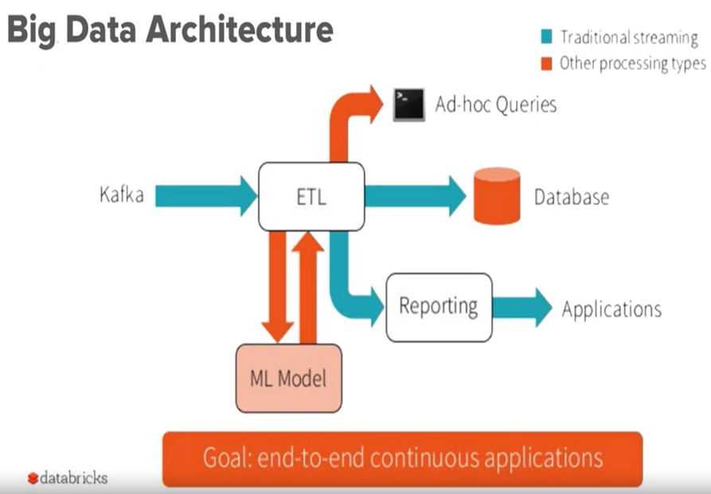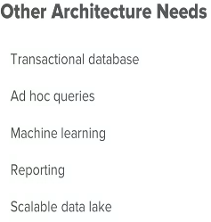

* **Kafka/ AWS Kinesis/ Azure event hub** 
  + Queue : Arriving data should not overload other infra
  + Data producers write data into topics and consumers read them
* **ETL**
  + Raw data [Data link backed by blob store like AWS S3, Azure blob]

🡪 Process 🡪 Database

* **Decoupled storage and compute**
  + Spin spark cluster 🡪 connect data 🡪 shut down after use
  + No necessity of cluster version control

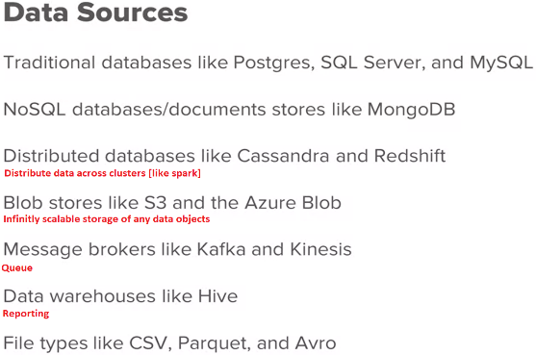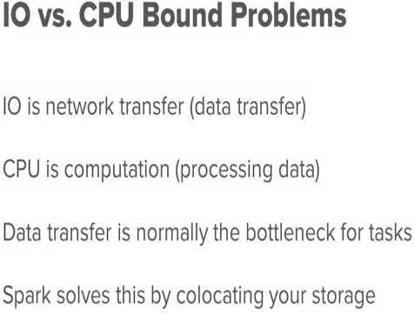**Computation bottlenecks**

* Task : count no of records in a 10 GB DB

Bottleneck : **fetching [IO]** 10Gb data from DB into cluster

* Task :Training ML model

Bottleneck : threading capacity of **CPU**

**Online Analytical processing :** Analyze data for business needs [Share market trend of last day]

**Online Transaction processing:** Transaction against DB in Real time [update profile, pay to merchant]

**Data Connection : Blob stores, JDBC**

**Spark uses-**

* **Predicate push down :** Process predicate level SQL operations [filter] at database level before fetching data into cluster – **Save network transfers and IO bottlenecks**
* **J**ava **D**ata **B**ase **C**onnection : Java API

**File formats:**

* CSV Storage in row format
* Parquet : Storage in column format – FASTEST method to read/ write data

**Compression types:**

* gz
* bzip : very high storage efficiency

**Spark is fast given its:**

* **In memory computation**
* **Knowledge of Data types operated on –** it helps optimizing logic behind data access, partitioning and shuffling
* **Flexibility to work with Semi structured data [JSON, NOSQL] awa tabular data [CSVs, RDBs]**

**Schemas and types:**

* **JSON:** Data schema evolves over time
* **USER DEFINED schema:** Save efforts of spark in schema inference [an extra bottleneck job]

**Database write & read operations:**

* **Parallelized using more partitions**
  + When data is written to DB, 1 connection per partition exists
  + **COALESCE [narrow transformation]**

CREATE OR REPLACE TEMPORARY VIEW <view1>

AS

SELECT /*+ COALESCE(1) */ *

FROM <table1>

* + **Partition[wide transformation]**

CREATE OR REPLACE TEMPORARY VIEW <view1>

AS

SELECT /*+ REPARTITION(8) */ *

FROM <table1>

**Managed and unmanaged tables**

**Use unmanaged/ external** table when

* we want data to persist after shutting cluster

**Use managed** table when

* 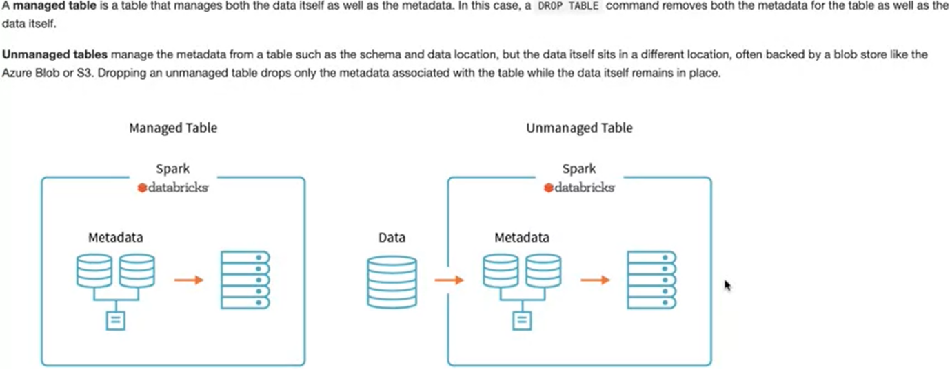Data is ephemeral

### **M​odule 3 Readings**

* [Why You Should Care about Data Layout in the Filesystem](https://databricks.com/session/why-you-should-care-about-data-layout-in-the-filesystem)
* [Lessons From the Field: Applying Best Practices to Your Apache Spark Applications](https://www.youtube.com/watch?v=iwQel6JHMpA)
* [W​orking with Complex Data Formats with Structured Streaming in Apache Spark 2.1: Part 2 of Scalable Data at Databricks](https://databricks.com/blog/2017/02/23/working-complex-data-formats-structured-streaming-apache-spark-2-1.html)

**WEEK 4 REAL WORLD ML MODEL - REGRESSION AND CLASSIFICATION**

**TRANSALATING BUSINESS PROBLEM TO DATA PROBLEM IS MOST IMPORTANT 21 CENTURY BUSINESS PROBLEM**

**Spark applications :** Graph processing, ML, streaming

**ML applications:**

Real time fraud detection

NLP : Classify medical records, chatbots

Computer vision : Medical image analysis, self-driven cars, facial recognition

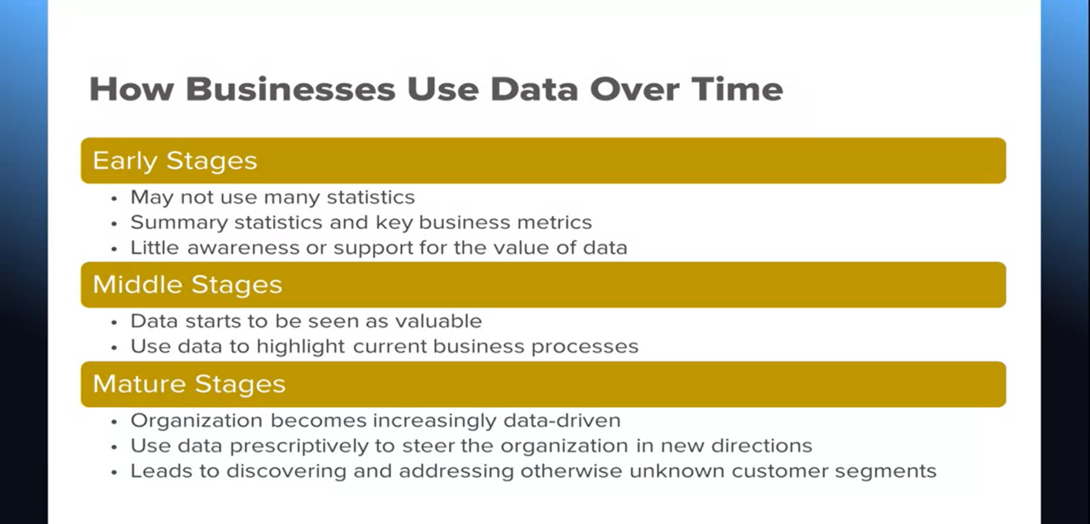

**Churn analysis**

**What is churn?** No purchase, No web visit

**How to predict?** Lesser visits, newer customers

**Predict?** Future purchases

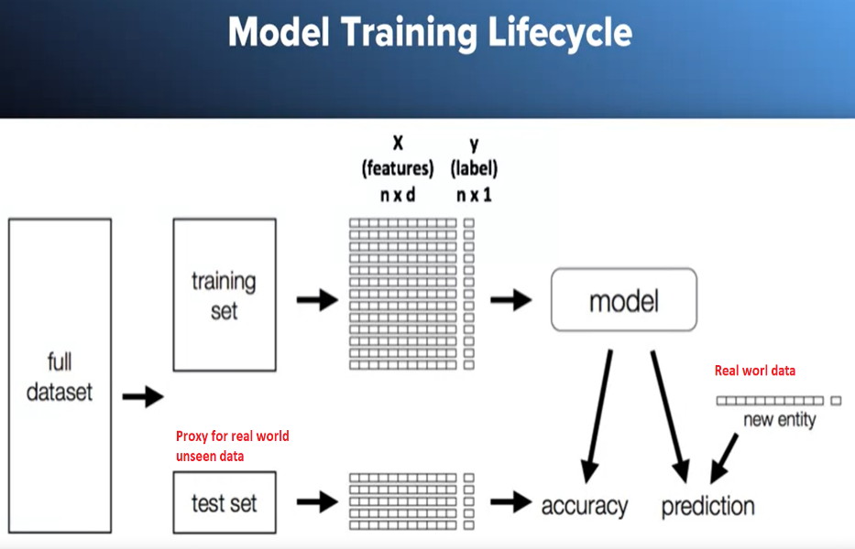

**Machine learning** is array of techniques that learn patterns without explicit programming. It maps features [customer history] to outputs [probability of churn]

* Supervised learning : labeled data – regression[predict continuous value on scale], classification [predict label category]
* Unsupervised learning : unlabeled data – clustering [learn structure of data and reveal data segments]

**Baseline model** [like average value] is comparison benchmark for trained ML model

**Choice of model**

* Ask stakeholders if they want **interpretable model** [contribution of independent features to prediction – Decision tree, Linear regression] or Accurate model [NN]
* Assumptions made by algorithms about data [eg. Linear regression assumes linear relation between I/O]

**SQL**

1. **USE <database>**
2. **DESCRIBE <tableName>**
3. **CREATE TABLE <tableName>**
4. **CREATE OR REPLACE TABLE <tableName>**
5. **CREATE OR REPLACE VIEW <viewName>**
6. **CREATE OR REPLACE TEMPORARY VIEW<tableName>**
7. **USING <filetype for creation>**